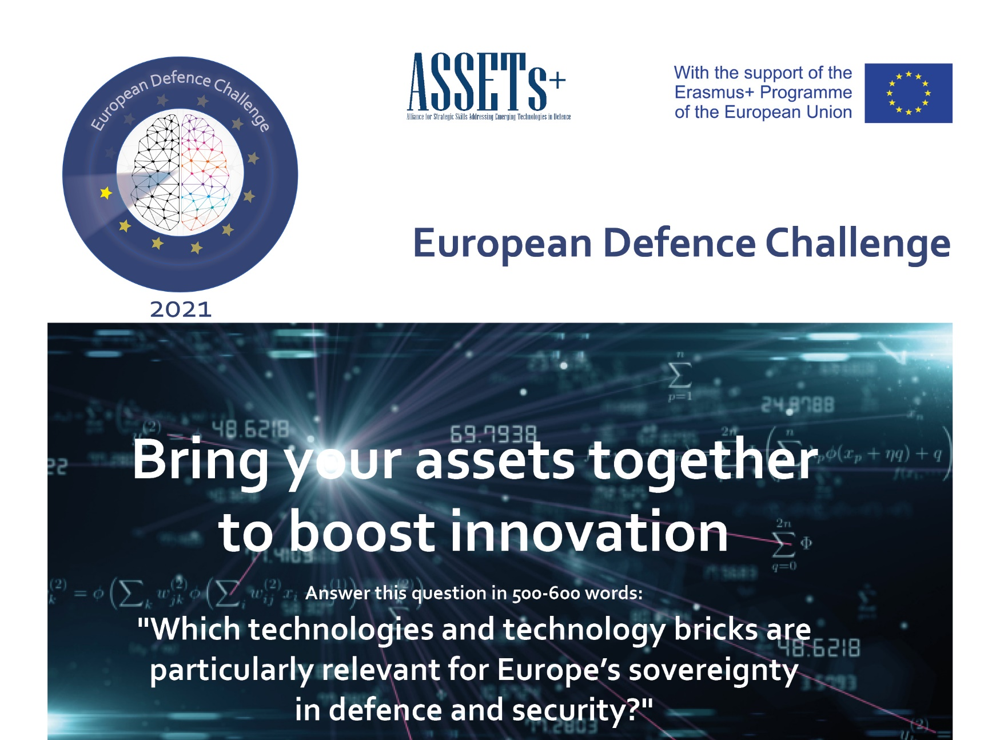
technologies #baies #C4ISTAR

The Challenge  The European Commission has declared technology as  the EU’s top priority for the next five years.  More particularly, one key objective is the mastery and  ownership of key technologies in Europe.  With this objective in mind the European Defence Challenge asks the students of Europe to propose one or more work approaches dealing with topics such as artificial intelligence, autonomous vehicles, batteries, cybersecurity, chip technologies, control, robotics, signal and image processing, and related to defence technologies within the framework of the question mentioned above.  Please defend your proposal by including socio-economic,  political and/or environmental aspects as much as possible. | Participant # 1  Name Click or tap here to enter text.  University Click or tap here to enter text.  Country Click or tap here to enter text.  Email Click or tap here to enter text.  Participant #2  Name Click or tap here to enter text.  University Click or tap here to enter text.  Country Click or tap here to enter text.  Email Click or tap here to enter text.

European Defence Challenge
Headline: Click or tap here to enter text.robotics #autonomous vehicles #chip technologies #batteries #C4ISTAR

